**SR 4.1: Algorithm Implementation: Sort algorithm**

**STEP 1**

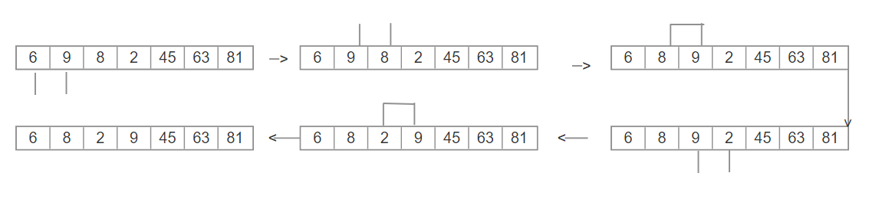

* Between 6 and 9 = No swipe
* Between 9 and 8 = swipe
* Between 9 and 2 = swipe

**STEP 2**

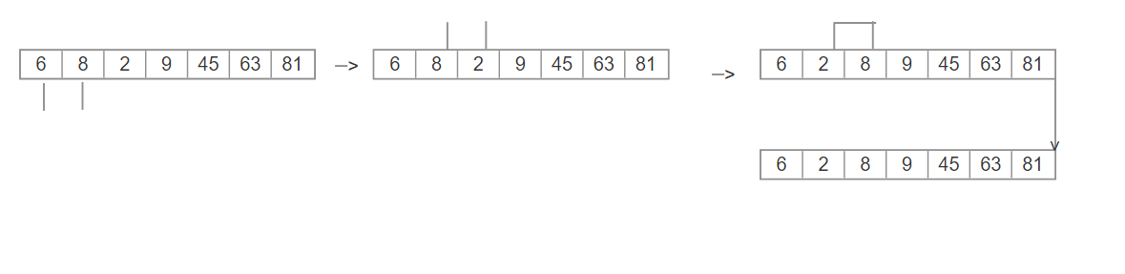

* Between 6 and 8 = No swipe
* Between 8 and 2 = Swipe

**STEP 3**

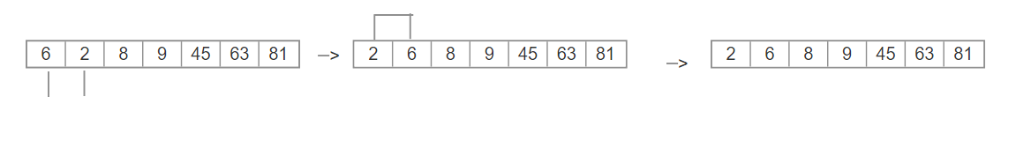

* Between 2 and 6 = Swipe

**HEAP DATA SORT ALGORITHM**

**TREE DIAGRAM**

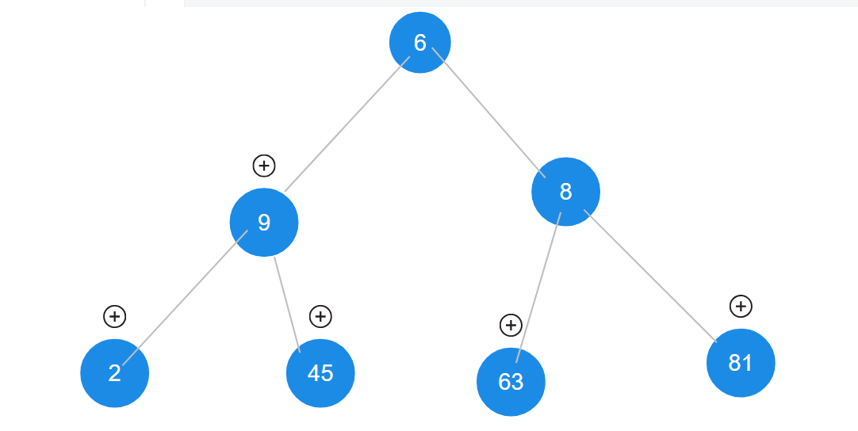

**HEAP 1**

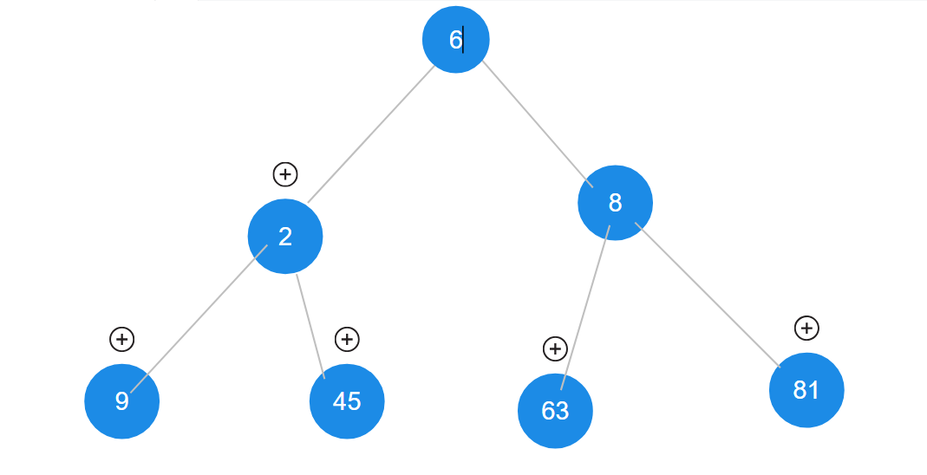

* Swipe 9 and 2

**HEAP 2**

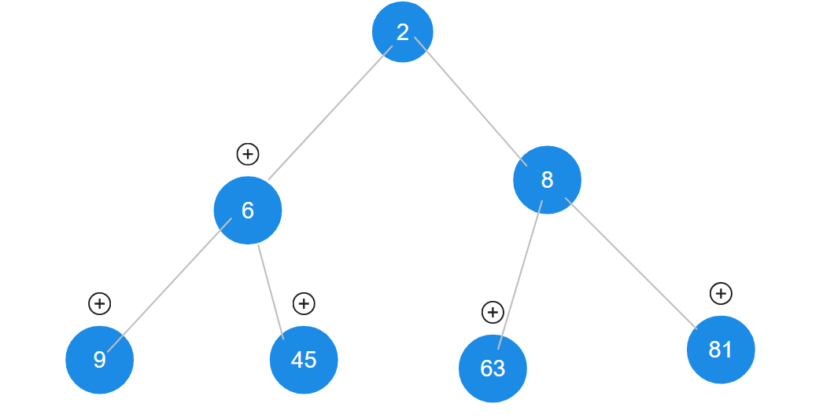

* Swiped 6 and 2